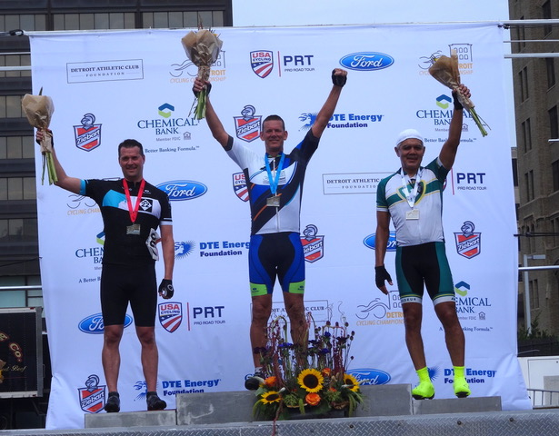

The second annual Detroit Cycling Championship presented by the DAC Foundation took place on Saturday July 14, 2018. President M. Roy Wilson of Wayne State University was among the many cyclist who came out for the event at Beacon Park in downtown Detroit. President Wilson made the podium, finishing 3rd,  in the DAC Members Race. Congratulations President Wilson! Way to be WARRIOR STRONG!