**Wayne State University celebrated the DTE Energy Foundation's generous gift**

On Thursday, March 3, 2016, Wayne State University celebrated the DTE Energy Foundation's generous support of the College of Engineering, Center for Latino/a and Latin American Studies, and Mike Ilitch School of Business at the Marvin I. Danto Engineering Development Center.

The DTE Energy Foundation awarded nearly $1.4 million in grants as part of the Foundation’s efforts to power the Michigan economy by ensuring graduates have the skills and talents to achieve career success in the state. The DTE Energy Foundation grants are part of Wayne State University’s $750 million Pivotal Moments fundraising campaign.

Wayne State University President M. Roy Wilson and DTE Energy President and COO Steve Kurmas gave remarks stating the importance of this partnership.

“*Our partnership with the DTE Energy Foundation supports Wayne State’s mission of providing students with access and opportunity*,” said Wayne State University President M. Roy Wilson. “*Through these three initiatives, we will continue to help students reach their potential by breaking down financial and academic barriers on the path to graduation.*”

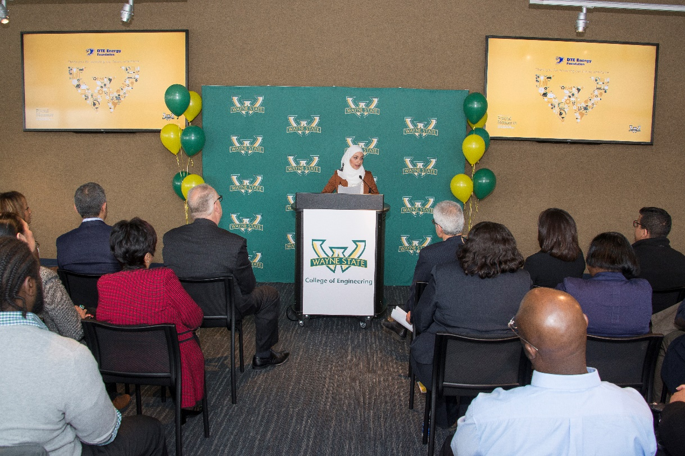One student from each college was invited to speak and had the opportunity to publicly thank the DTE Energy Foundation for their generous gifts and share their personal success stories as students at Wayne State University. The student chosen to speak on behalf of the Mike Ilitch School of Business was Salma Alazmeh, President of Volunteers for the Wayne State University HIGH (*Helping Individuals Go Higher*) Program.

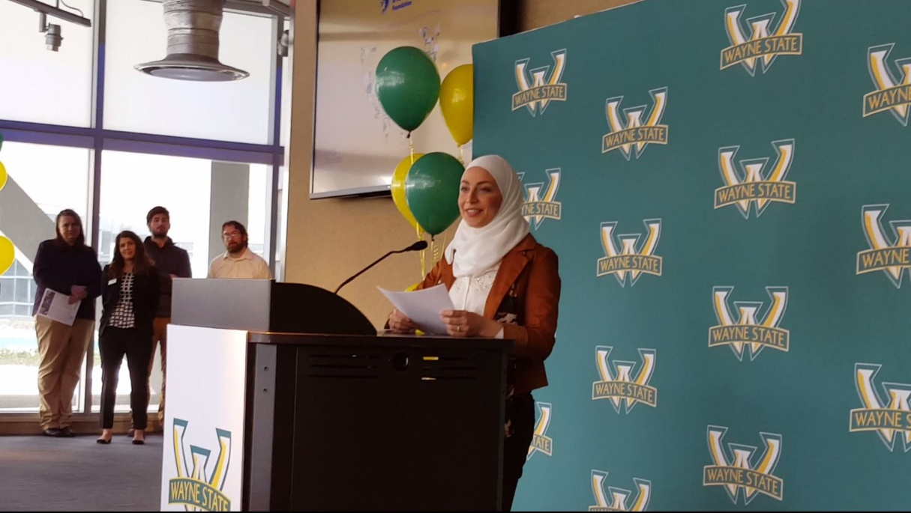

For more information about the event, visit: <http://wayne.edu/newsroom/release/2016/02/29/wayne-state-university-receives-nearly-14-million-from-dte-energy-foundation-to-improve-retention-and-graduation-rates-5808>

Other Related Links:

<http://ilitchbusiness.wayne.edu/releases.php?id=18807&date=2016-03>

<http://www.crainsdetroit.com/article/20160228/NEWS/302289974/dte-energy-gives-wayne-state-university-1-4m-in-grants-main-focus>

<http://michronicleonline.com/2016/02/29/wayne-state-university-receives-1-4-million-from-dte-energy-foundation/>

<http://www.dteenergy.com/foundation>